


Forms in
Qualtrics

Data Analysis
  - 2026 – I




The Qualtrics Environment
When you log in to Qualtrics, the first page you will see is the control panel. Here you can create and manage your projects. A project is built from a predefined survey template or from scratch (a new survey-built step by step by you). Within the control panel, projects are organized into folders on the left side of the page.
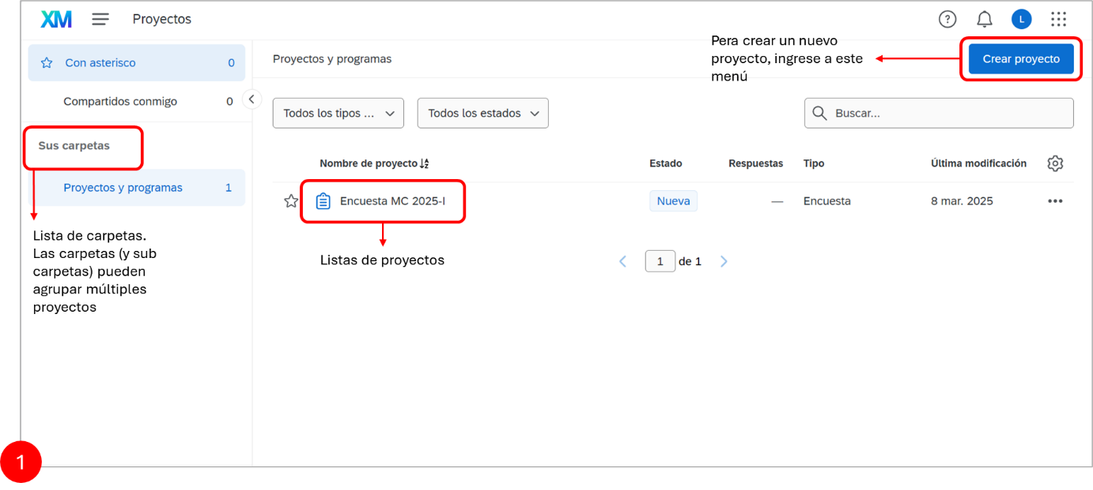
To create a new survey, go to the "Create Project" menu, then select creating a survey from scratch, and click the "Get started" button in the panel that appears on the right side of the page.
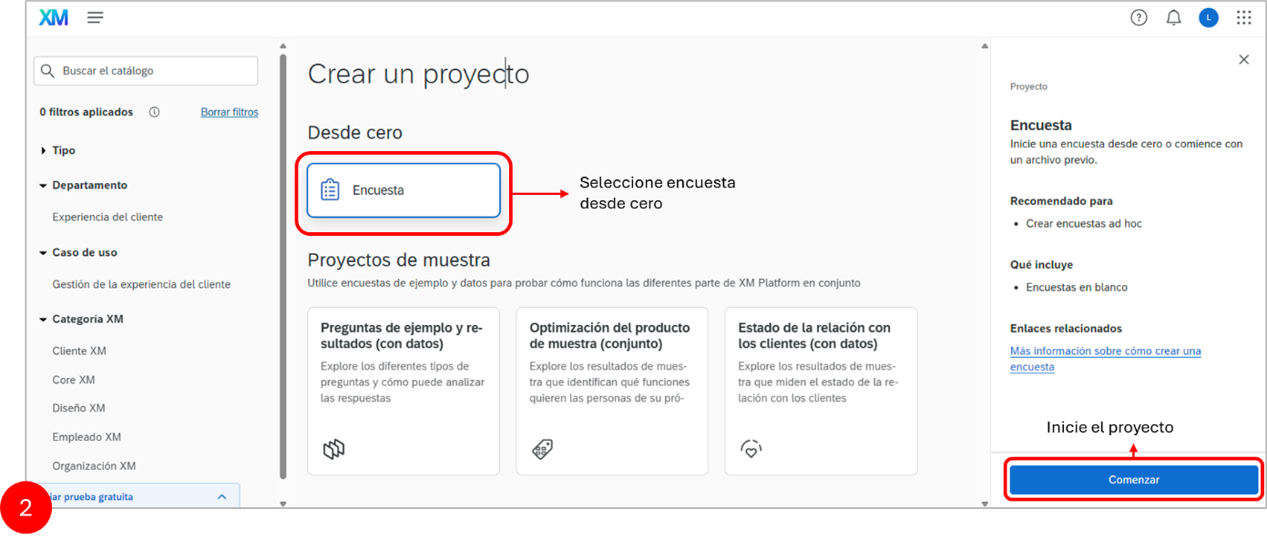
Assign a short name to your project and select "Start with a blank survey" from the templates menu. In addition to creating a blank project, Qualtrics offers three additional options: "Import a QSF File": lets you upload a survey in Qualtrics Survey Format (QSF). "Copy a Survey from an Existing Project": lets you duplicate one of your existing surveys and use it as a base for the new one. "Use a Survey from Your Library": lets you use existing surveys available in the Qualtrics Library.
After this, the project will appear on your control panel. Once the project is created, you can reorganize folders and subfolders to, for example, separate instruments with a qualitative versus quantitative focus. When you open one of your projects from the control panel, you will find the instrument development area. This page has 5 main tabs:
- In the Survey tab, you can edit the survey you have opened.
- In the Workflows tab, you can configure different types of notifications that will be triggered if a participant responds in a particular way (for example, selects a specific response option).
- In the Distributions tab, you can activate your survey and also have different options for how to distribute it. This is especially useful if you are conducting your research online.
- In the Data & Analysis tab, you can view individual responses or averages from your survey. However, to truly test your hypothesis, you will need to download the data and analyze it in Stata, R, SPSS, or another statistical software.
- In the Reports tab, you can create different visual representations of your survey results.
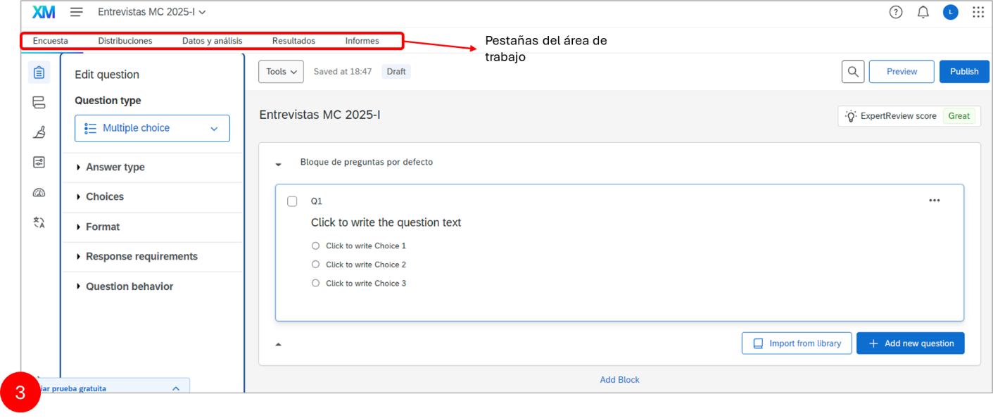
Within the Survey tab, you will find 6 tools to customize and optimize the questions in your instrument:
- Question Type: allows you to select the format or type of question to include in the survey. The available options are:
  - Multiple Choice: can be displayed as a traditional list of options or as a dropdown, selection box, etc.
  - Text Entry: used to collect open-ended responses from respondents. These responses can be long essays or short text.
  - Text/Graphic: can be used to add an introduction or instructions to your survey, or to display an asset such as an image.
  - Matrix: used to collect multiple pieces of information in one question. This type provides an efficient way to condense your survey or group similar items in a single question.
  - Slider: sliders allow respondents to indicate their level of preference with a draggable bar instead of a traditional button or checkbox.
  - Form Field: allows collecting standard form information such as name and email address.
  - Rank Order/Preference: used to determine each respondent's order of preference for a list of items.
  - Side by Side: allows asking multiple questions in a condensed table, providing an efficient way to shorten your survey while collecting the same amount of data.
- Response Type: defines whether respondents can select a single or multiple answer options. This allows adjusting response flexibility according to the instrument's needs.
- Choices: here you configure the different response options available to respondents. You can add, edit, or delete options. You can also use suggested options or edit multiple options at once.
- Format: determines how response options will be displayed, such as in a vertical list, horizontal, or dropdown format, depending on what is most appropriate for the form.
- Response Requirements: allows setting rules or validations for responses, such as making the question mandatory or setting specific criteria that responses must meet.
- Question Behavior: offers advanced settings such as adding display logic (show or hide the question under certain conditions), skip logic (skip questions based on responses), randomization of options, and value recoding.
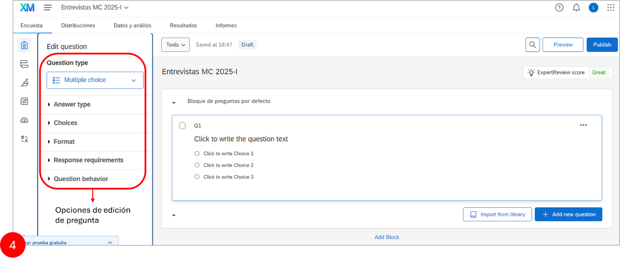

Creating Question Blocks
In Qualtrics, a question block is a set of (different types of) questions grouped within the same section of a survey. Blocks allow you to organize and structure surveys more efficiently, facilitating their management and modification. Each block can contain questions related to a specific topic or serve a particular function within the survey.
The advantage of organizing different parts of a survey into blocks is that specific functions available in Qualtrics can be applied to all the questions within the same block. One of the main advantages of this organization is that it allows, for example, randomly assigning 50% of participants to one form while the other 50% are assigned to another.
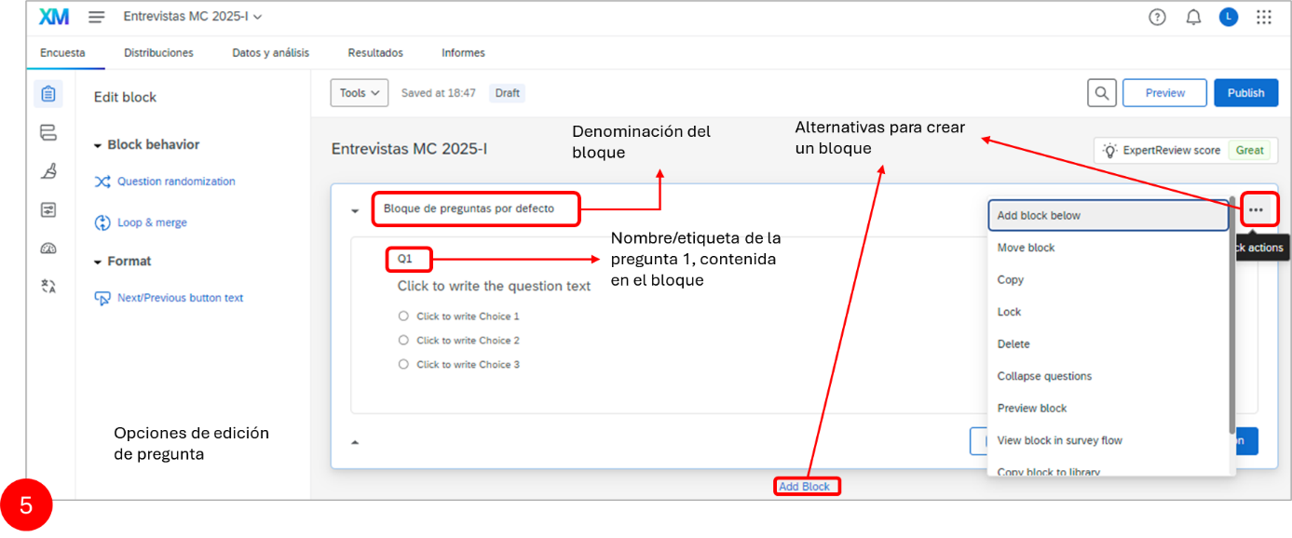

Example Questionnaire with Random Block Assignment
Following the instrument developed by Professor Dario Krpan, we will generate an instrument to investigate whether people's self-perception of time management can be influenced using default values, even when they did not receive an intervention that objectively changed their time management.
Oettingen, Kappes, Guttenberg, and Gollwitzer (2015) demonstrated that the combination of mental contrasting with implementation intentions (MCII) influences people to subjectively report more effective time management compared to those who did not receive this intervention.
More specifically, we will create a survey that will allow us to test whether setting participants' default answers in the time management questionnaire to "never" or "none" influences them to report less effective time management compared to setting these default responses to "very often" or "many".
Therefore, our goal will be to build a simple survey consisting of 5 time management items taken from Oettingen et al. (2015). All participants in this experiment will respond to these 5 items. However, for half of the participants (Condition 0), the default response will be "never" or "none", while for the other half it will be "very often" or "many" (Condition 1). Each participant will be randomly assigned to one of the two experimental conditions. Applying this instrument will allow us to study the following hypothesis:
Participants whose default responses in the time management questionnaire are "never" or "none" will report less effective time management compared to participants whose default responses are "very often" or "many".
For this purpose, the first block of the form will contain the informed consent form that participants must read to confirm their willingness to participate in the experiment.
The second and third blocks will include the five items of the time management questionnaire. In the second block, the default options will be set to "never" or "none" (Condition 0), while in the third block the default options will be set to "very often" or "many" (Condition 1). The organization of the instrument must allow randomly assigning 50% of participants to Condition 0, while the other 50% will be assigned to Condition 1.

Creating 3 Blocks
In addition to the default block, create 2 more blocks, for a total of 3 question blocks. Then rename the blocks as follows: "Informed Consent", "Condition 1", and "Condition 0".
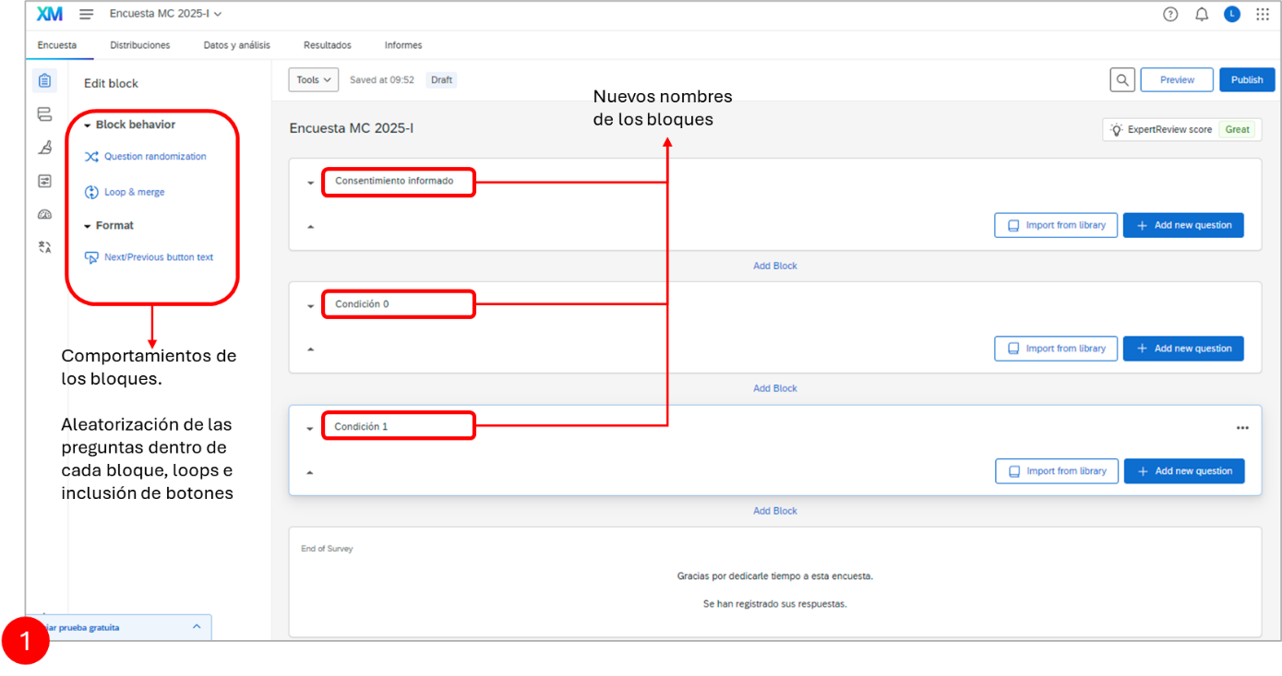

Creating the Informed Consent
With the 3 question blocks created, we need to create the consent form. To do this, first change (or add) a question of type "Text or Graphic". To write the question, click on the default question created in the block, and then click on "Rich Content Editor".
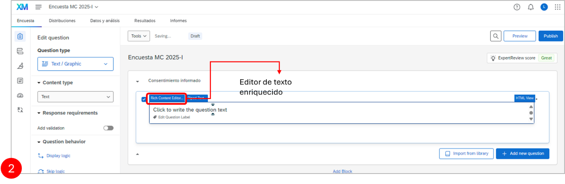
Inside the text editor, include the following informed consent template:
¡Gracias por tomarte el tiempo de participar!
En este estudio, se te pedirá que respondas 5 preguntas sobre cómo administras tu tiempo. El estudio debería tomar aproximadamente 5 minutos para completarse.
Puedes retirarte del estudio en cualquier momento sin necesidad de dar explicaciones. Tu privacidad es muy importante.
Solo el investigador principal y su supervisor tendrán acceso a los datos. Los resultados de este estudio se presentarán en conferencias y se publicarán en revistas, así como en la tesis de maestría del experimentador. Normalmente, los resultados se presentan en términos de grupos de individuos. Si se presentaran datos individuales, estos serían anónimos, sin ningún medio para identificar a las personas involucradas.
Este proyecto está en línea con las directrices éticas establecidas por el Comité de Ética en la Investigación de la Universidad Externado de Colombia. Si tienes alguna pregunta antes de comenzar la encuesta, no dudes en contactar a XXX en XXX.
IMPORTANTE: para participar en este estudio, debes ser mayor de 18 años. Si has leído todo lo anterior y estás de acuerdo en participar, selecciona "Sí, quiero participar".
Now you need to configure the response option. To do this, first open the "Builder" tab (where you can find different features to edit questions) and then click on "Multiple Choice" under "Question Type". The question type we need is "Multiple Choice".
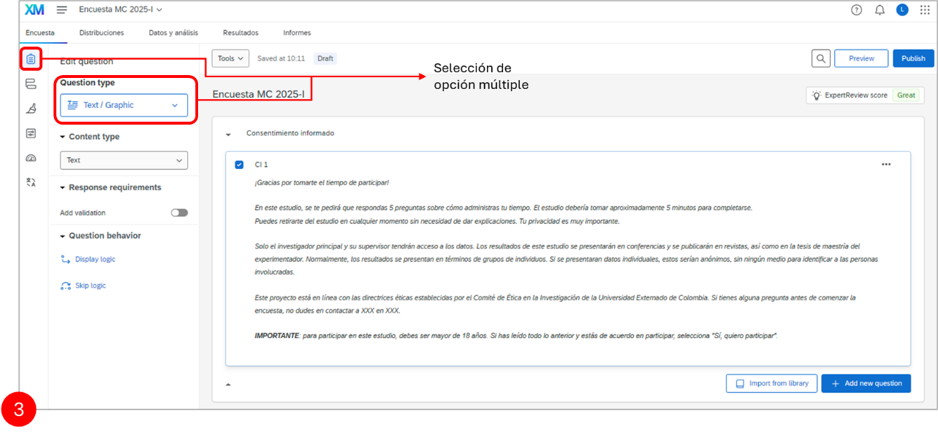
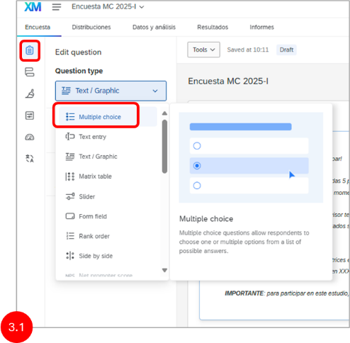 | After adding the multiple choice question, default multiple choice options will be generated. These should be reduced to 2 options. To reduce the number of response options to 2, click on "Edit Multiple" and then, in the "Edit Multiple Answer Choices" window that opens, type "No, I do not want to participate" and "Yes, I want to participate". This will reduce the number of options to the 2 desired. Click "Apply" when done.
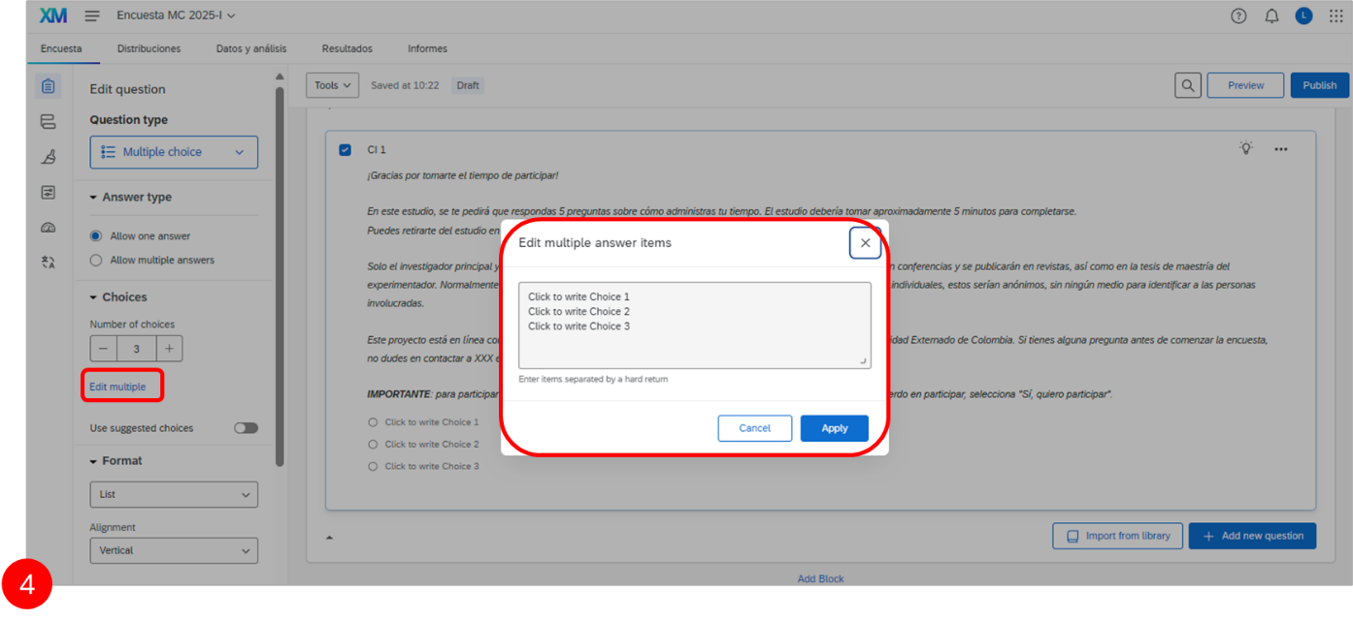
Now there are 2 response options for the informed consent. Next, it is necessary to modify how the options are presented and to adjust behavior. For example, in the "Format" tab, you can display the response options as a List, Dropdown, or Selection Box. You can also change their alignment from vertical to horizontal or column. Additionally, if you want to require participants to answer this question, go to the "Response Requirements" tab, click "Add Requirements", and select "Force Response".
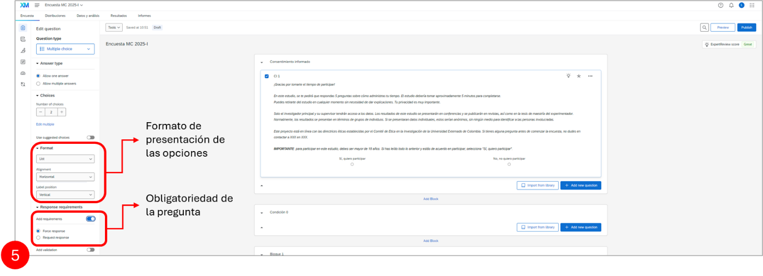
Additionally, we need to make sure that participants who select "No, I do not want to participate" are immediately taken to the end of the survey, as they have chosen not to participate and should not be shown the survey. To do this, in the "Survey Builder" tab, scroll down to "Question Behavior" and select "Skip Logic".
Then, when the "Skip Logic" window opens, you will need to configure "Skip to" as "End of Survey" if "No, I do not want to participate" "Is Selected". Finally, press "Confirm" to set the skip logic.
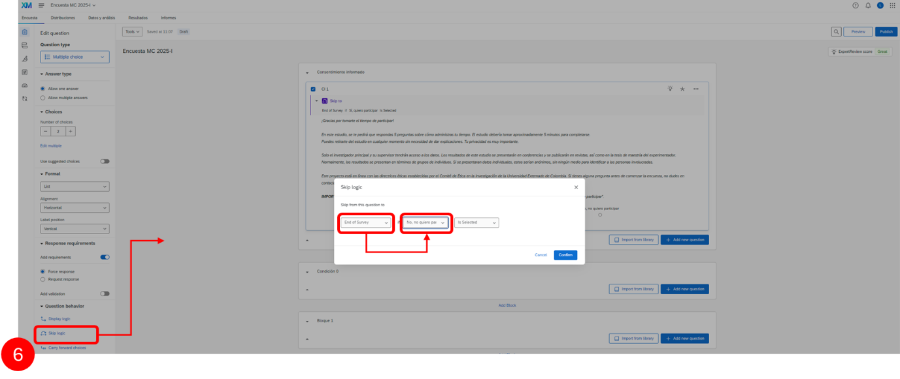
Finally, to complete the consent form, we need to rename the question. Currently, the question is labeled "Q1". However, it is recommended to give each question a unique name so it can be easily recognized in the data analysis. To rename the question, click on "Q1", and the field where you can change the name will open (for example, you can name the question "Consent").
Condition
Now we will create the survey consisting of the following 5 items, with the default options set to "never" (items 1-4) or "none" (item 5):
- During the last 7 days, I managed time easily.
- During the last 7 days, I kept my appointments easily.
- How often did you feel in control during the last 7 days?
- How often did you feel relaxed during the last 7 days?
- How many projects did you complete during the last 7 days?
To create the first item, click on "Add New Question" below the "Condition 0" block and select the following question type: "Slider".
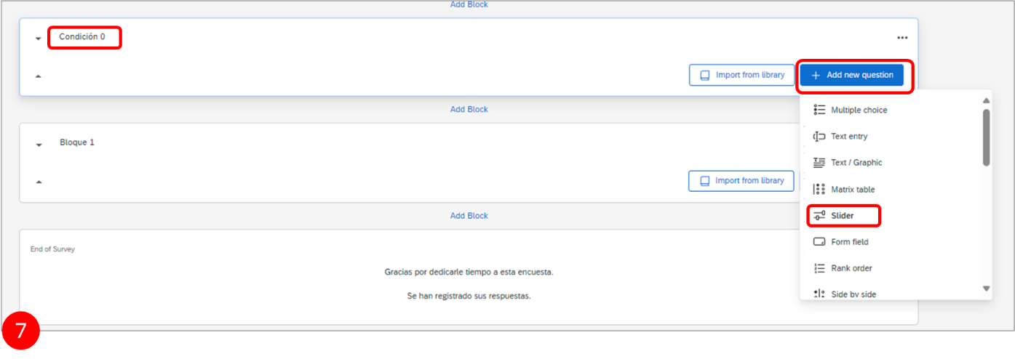
Then, by clicking on "Click to write the question text", you can open the text field and copy and paste Item 1: "1. During the last 7 days, I managed time easily." Since only one slider is needed to answer the question, you will have to remove the 2 redundant sliders (created by default). To do this, go to "Statements" under "Question Type" and set the number of statements to 1.
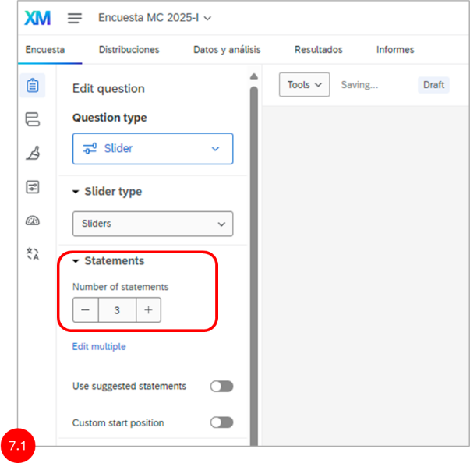 | Then, to set the slider response options to "Never" and "Very Often", scroll to the "Format" menu, click "Add Labels", and set the number of labels to two. Finally, to enter the response options, click "Edit Multiple" and, in the "Edit Multiple Response Items" window that appears, enter the two response options. When finished, do not forget to press Apply.
With the first item created, it is now necessary to manipulate the default slider options. To do this, in the "Survey Builder" tab, find the "Question Behavior" menu and click "Default Choices". When the "Edit Default Choices" window opens, move the slider to the position you want to set as default and press "Save". This completes the first item for Condition 0. Now the other 4 items must be created using the same procedure used for Item 1. You can use the "Copy" function to copy and paste the first question 4 times and use it as a base for creating the remaining items, instead of starting from scratch.
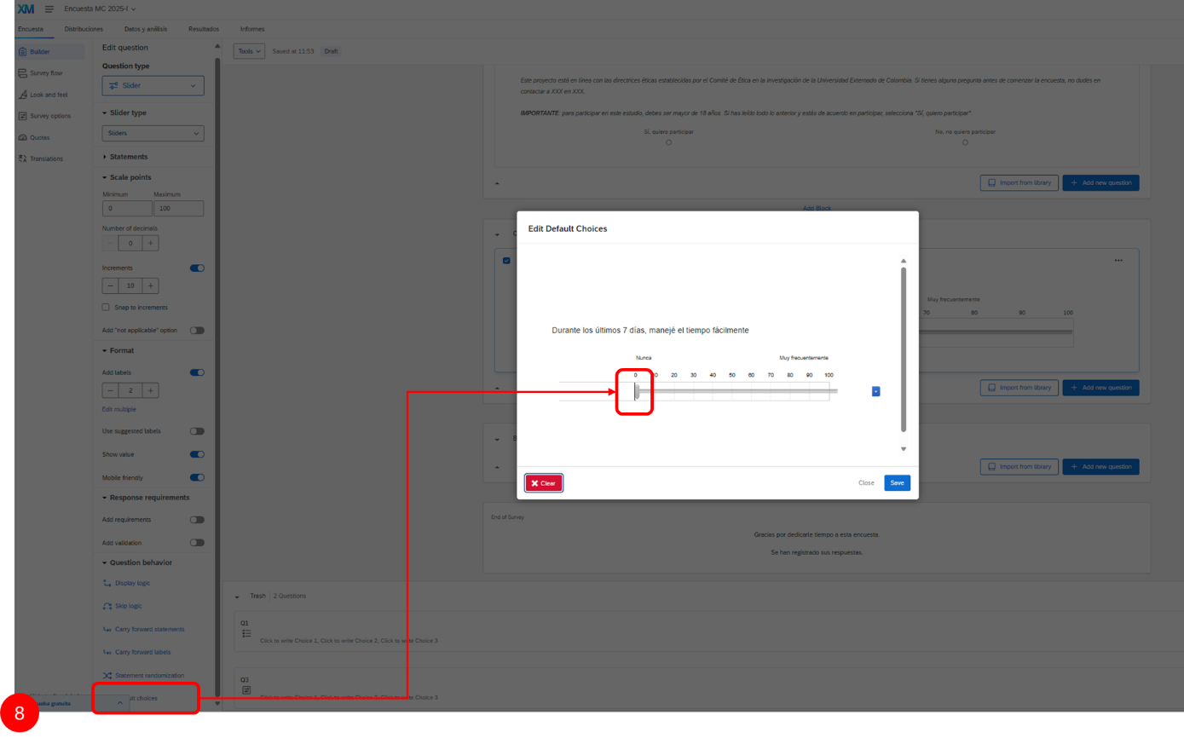

Condition 1
The Condition 1 question block is the same as Condition 0, except that the default options are configured differently. Therefore, instead of recreating the Condition 1 items manually, we will simply copy Condition 0 and change the default options.
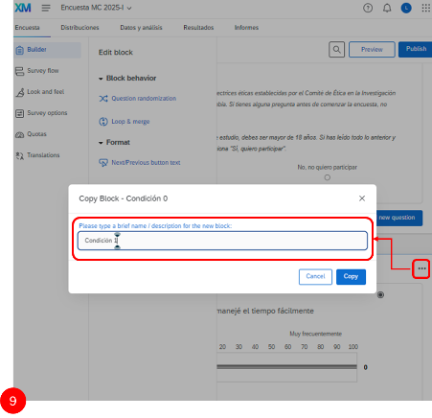 | To do this, first, since Condition 1 will not be created manually, it will be necessary to delete the "Condition 1" block. Then, in the block options of Condition 0, select "Copy Block", and modify the name of the copy. Finally, for each of the sliders in the new block, modify the default value position, moving it from the far left ("never") to the far right ("very often"). Also, do not forget to give each question a unique name so you can recognize it in the data sheet.

Block Randomization
We have created 2 Condition Blocks (0 and 1), but participants in our experiment will be randomly assigned to only one of them.
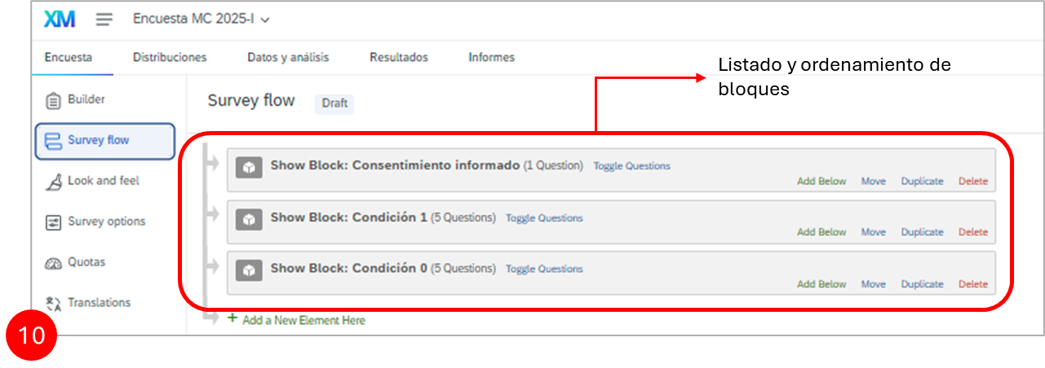
For this you must go to the Survey Flow section. Here you can organize and control the structure of the survey. In this section, you can manage content blocks, such as questions or experimental conditions, through options to move, duplicate, or delete elements, and you can add new functionalities such as "Randomizer" to randomly assign participants to different conditions.
To use this feature, first click on the "Add a New Element Here" menu and select "Randomizer". The randomizer must be moved below the "Informed Consent" block in the survey flow. To do this, press "Move" and hold down the left mouse button (it is very important that you keep the mouse button held down, otherwise you will not be able to move the randomizer). The field will turn green, and you must drag it below the "Informed Consent" block.
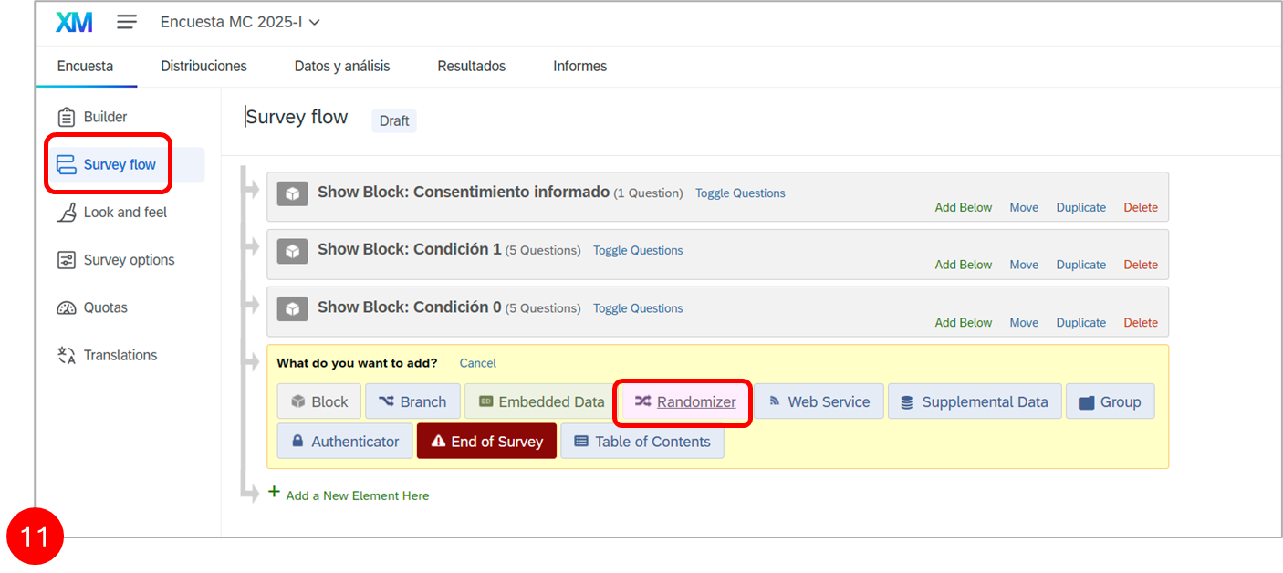
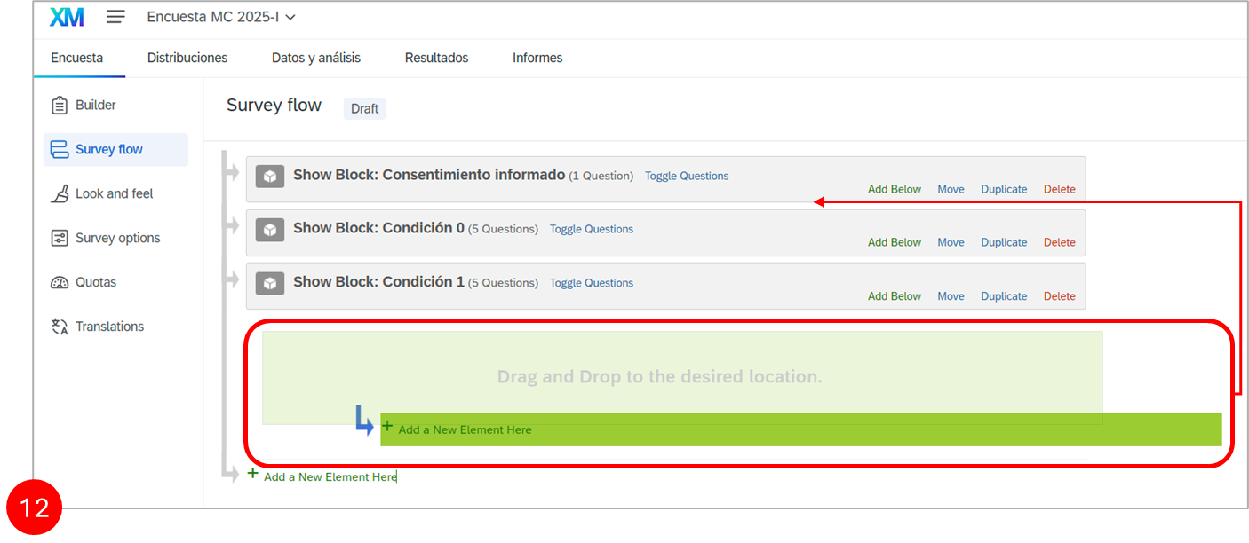
Now it is necessary to convert the "Condition 0" and "Condition 1" blocks into "Randomizer" elements. To do this, first press "Move" within the "Condition 0" block (similar to how it was done with the randomizer in the previous example) and then drag it to "Add a New Element Here". Do the same with "Condition 1".
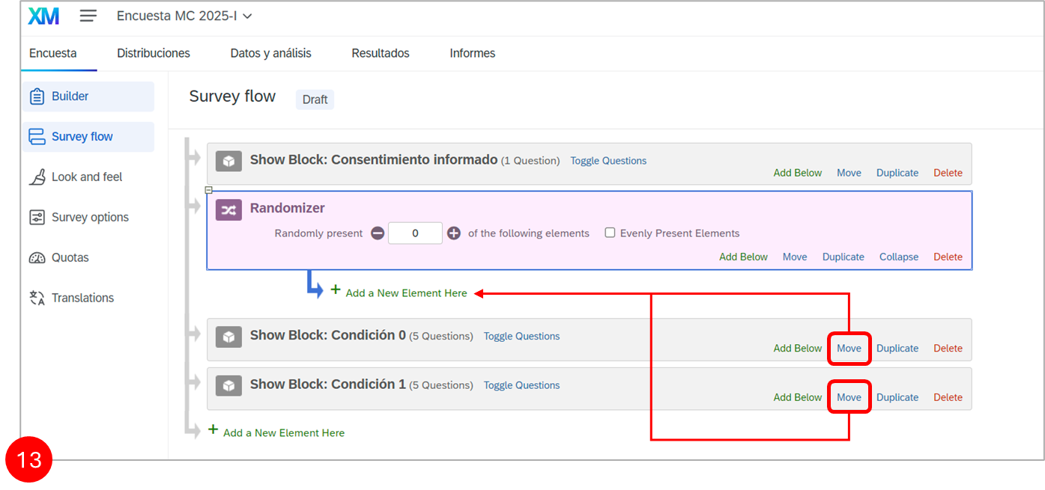
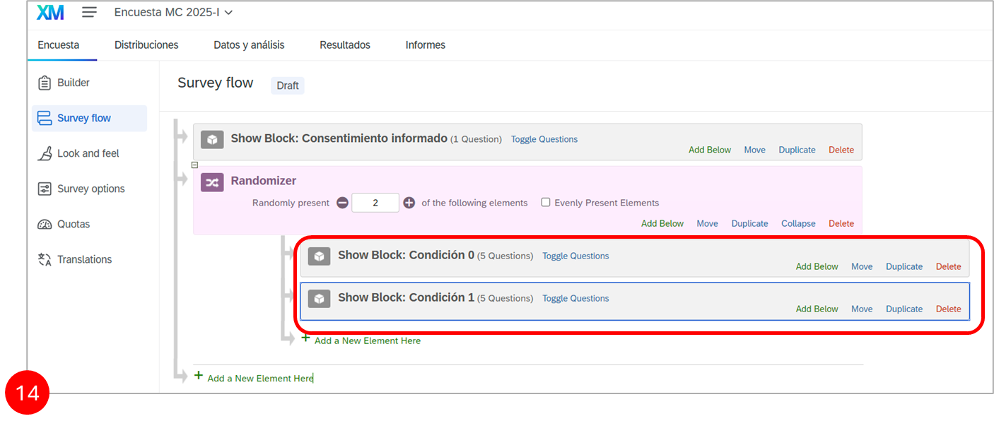
Finally, select "Randomly present 1 of the following elements" within the "Randomizer". Also, check the "Evenly Present Elements" option. These features will ensure that only 1 condition is randomly shown to each participant and that a similar number of participants complete each of the two conditions. When finished, click the "Apply" button in the lower right corner of the page.
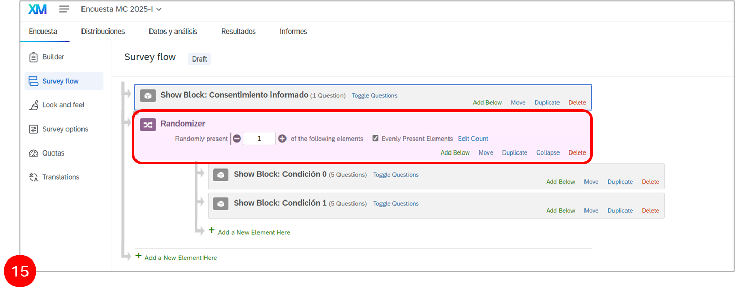

Creating a Variable to Store Condition Assignment
When a participant completes your form and you download the data, the dataset will not by default include a variable indicating which condition the participant was assigned to. However, this variable is important, as it constitutes the "independent variable" you will need for your statistical analyses. Therefore, it is necessary to create a variable using the "Embedded Data" functionality, which allows recording additional information beyond the responses to the questions.
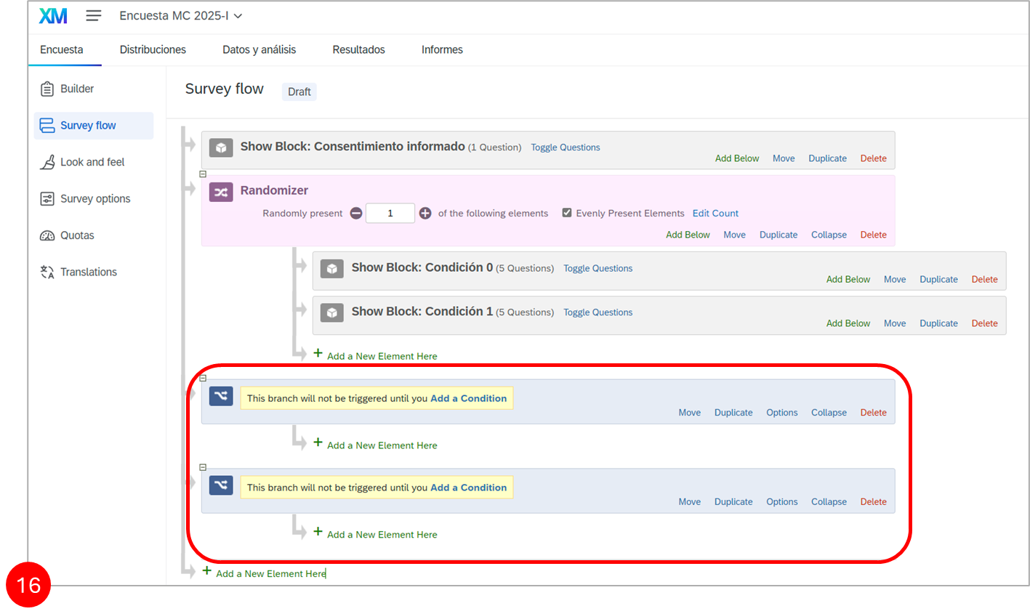
First, in the "Survey Flow" tab in the left menu, click on "Add a New Element Here" and select "Branch". Create 2 branches, one for each condition of the form.
Now that the 2 "Branch" elements have been created, you will need to click on "Add a Condition" within each branch to determine the conditions under which they should be triggered. For the first branch, select the following logic:
- "Then, trigger the branch if question C0-1 (the first question in Condition 0) and Choice 1 (or simply '1', or sometimes '1 ', depending on the operating system and browser) and is displayed."
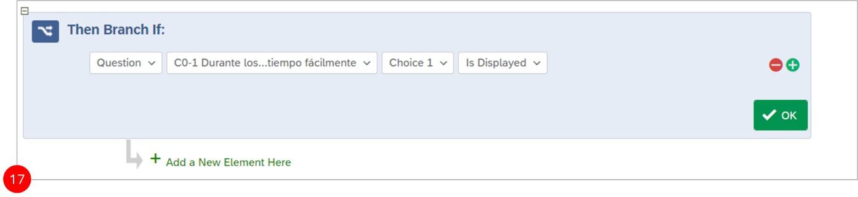
For the second branch, the logic to select is: "Then, trigger the branch if question C1-1 (the first question in Condition 1) and Choice 1 (or simply '1', or sometimes '1 ', depending on the operating system and browser) and is displayed."
Click "OK" in the lower right corner of each branch to save the logic. These rules mean that the first branch will be triggered whenever participants are assigned to Condition 0 (because the first question in Condition 0 is shown when that condition is active) and the second branch will be triggered whenever participants are assigned to Condition 1 (by the same logic with Condition 1).
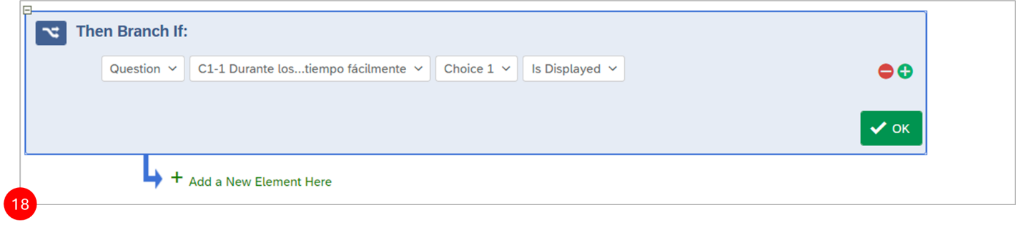
Now we need to create 2 "Embedded Data" elements to record that a participant is in Condition 0 when the first branch is triggered, and that a participant is in Condition 1 when the second branch is triggered. To create the 2 "Embedded Data" elements, click on "Add a New Element Here" twice, and then, for each element, select "Embedded Data".
After this, you will need to move the first "Embedded Data" element inside the first "Branch" and the second "Embedded Data" element inside the second "Branch". To do this, press "Move" within each "Embedded Data" element and drag it to "Add a New Element Here" under the corresponding branch.
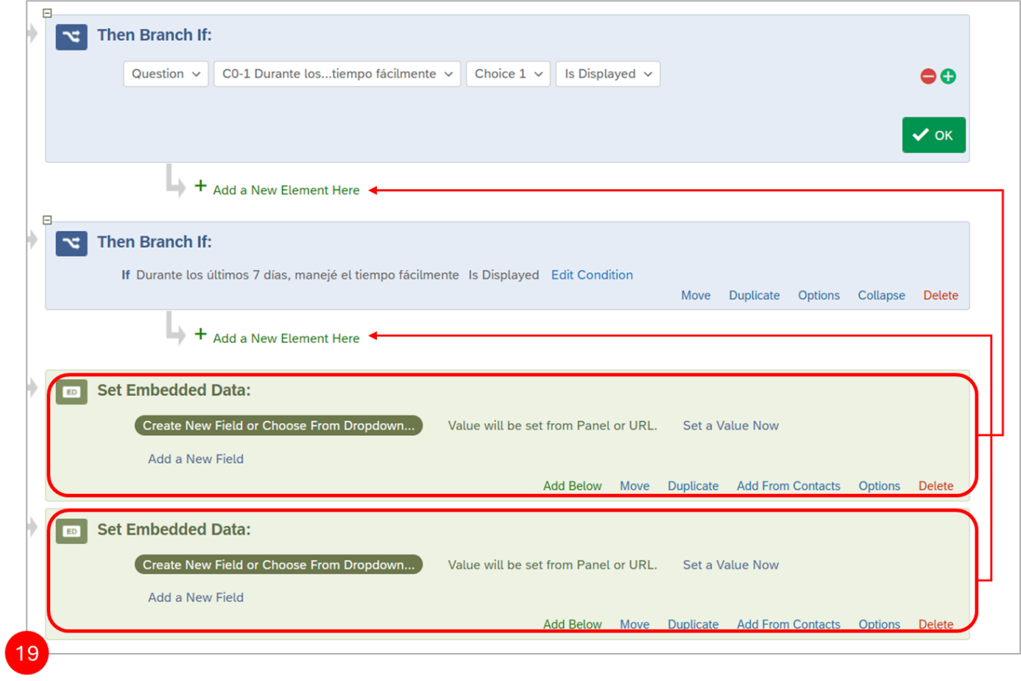
The next step is to "Set Embedded Data". To do this, in each "Embedded Data" element, click on "Create new field or choose from dropdown", and type "Condition" in the text box. Then click "Set a value now" and enter 0 for the first "Embedded Data" element and 1 for the second "Embedded Data" element.
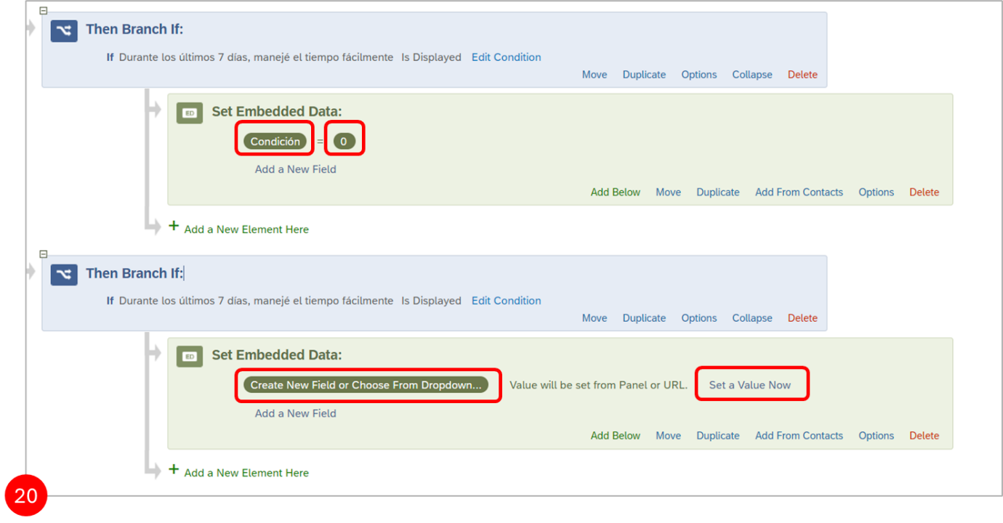 Finally, when done, click the "Apply" button hidden in the lower right corner of the page. Now, these embedded data elements will create a variable called "Condition", where 0 will be assigned to all participants assigned to Condition 0 and 1 to participants assigned to Condition 1. This variable will appear in your dataset when you download it.
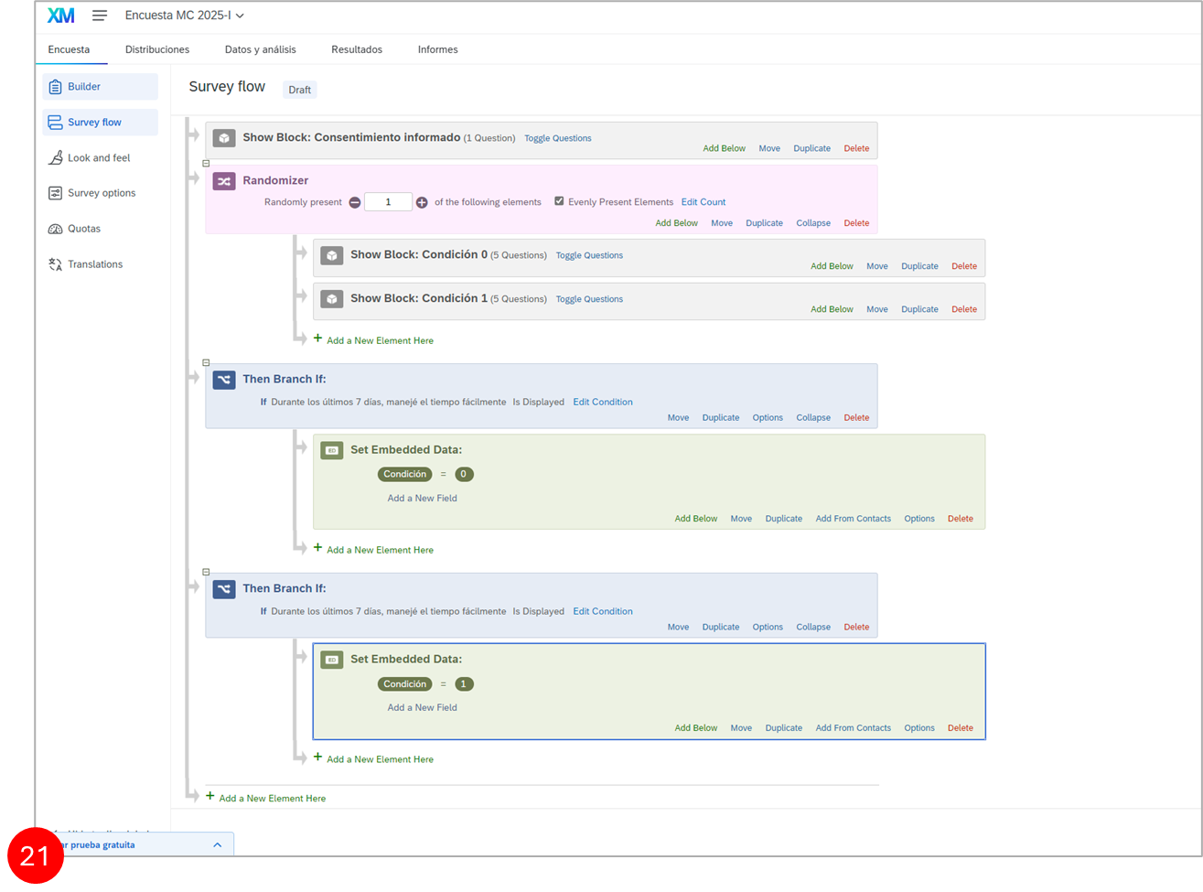

Form Preview
Before activating the survey and sending it to participants, it is important to test it ourselves to make sure it looks good and does exactly what we want it to do. To test the survey, we will use the preview function. Press "Preview" and then answer the questions yourself to confirm that everything works correctly.
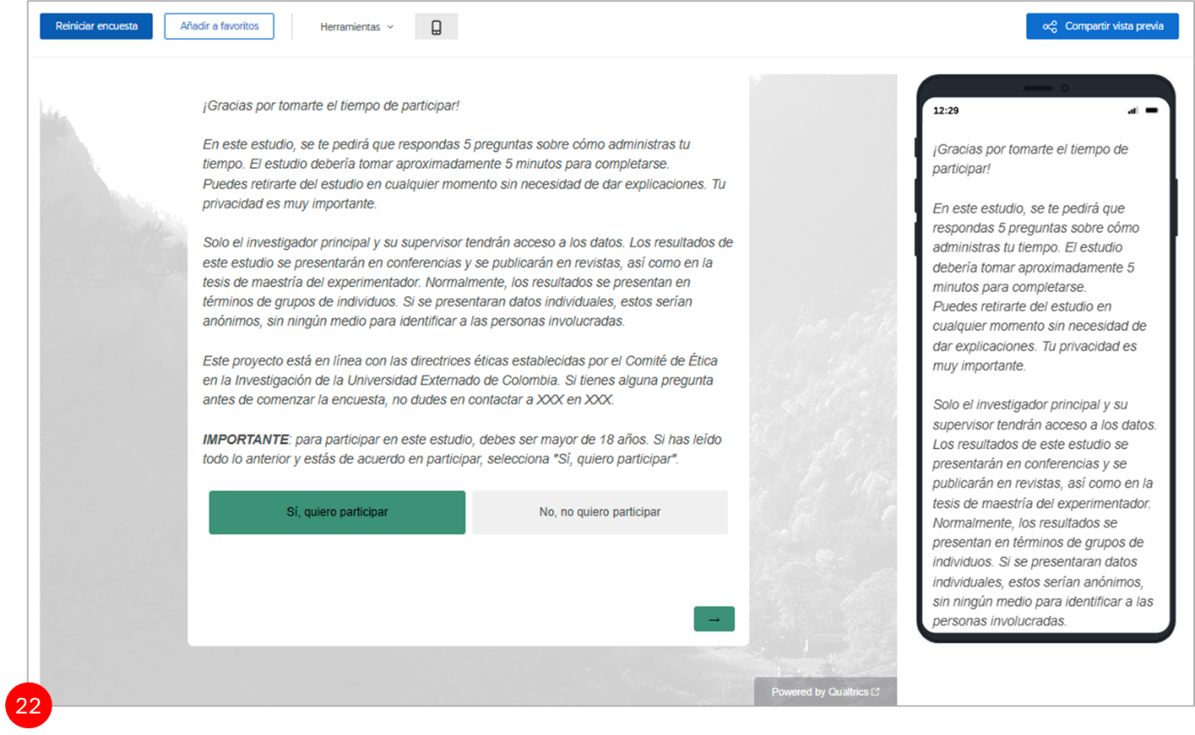
Before showing how to launch and distribute the survey, it is important to review the "IQ Score". This tool evaluates aspects such as survey length, whether it is suitable for mobile devices, the number of grammatical conjunctions in question text, among others. It then calculates how "smart" the survey is overall.

Form Distribution
When you open the "Distributions" tab, you will see that Qualtrics offers four main survey distribution options:
- Email
- Web
- Social
- Mobile
Qualtrics also provides the option to purchase participants (Online Panel) who meet specific demographic criteria. However, it is recommended to use participant recruitment platforms such as Prolific Academic or Amazon Mechanical Turk for experiments, unless you need very specific participant groups that you cannot reach through these platforms.

